
Challenging Topics in the New GCSE
NCP19-19

Modelling with Quadratics - Camber

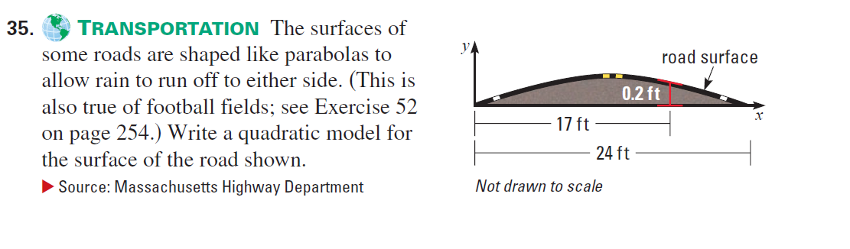

Model the road surface of a single carriageway with two lanes in the UK using a quadratic model.

--------------------------------------------------------------------------------------------
Information
Single carriageway with two lanes (one in either direction): 5.5m to 7.3m, depending on the traffic and number of access points on the road (like driveways). If it’s a bus route the minimum is 6m (residential street) or 6.75m or 6.9m for other routes depending on the bus. Standard residential streets can be as narrow as 5.5m, as can be rural roads.
Road cambers are usually calculated at around 3 cm of road surface elevation per 30 cm of road width. Whilst essential for maintaining road condition and safety for motorists, it does represent a challenge for learner drivers on the driving test.

https://www.drivingtesttips.biz/road-camber.html

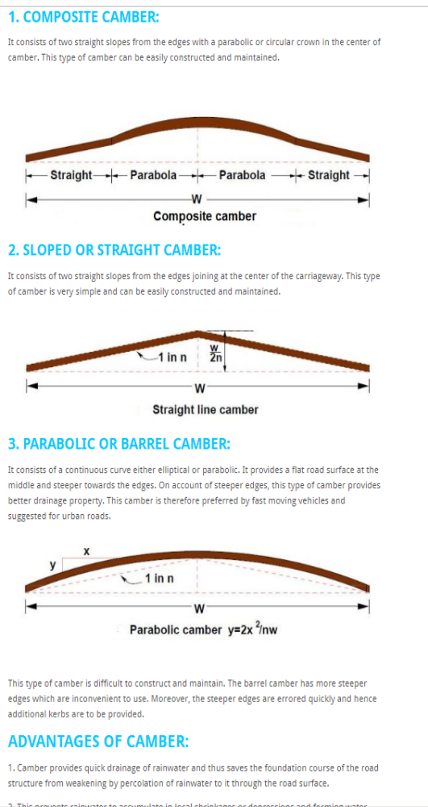
http://dailycivil.com/types-road-camber-advantages-methods-providing-camber/

