Find the Function
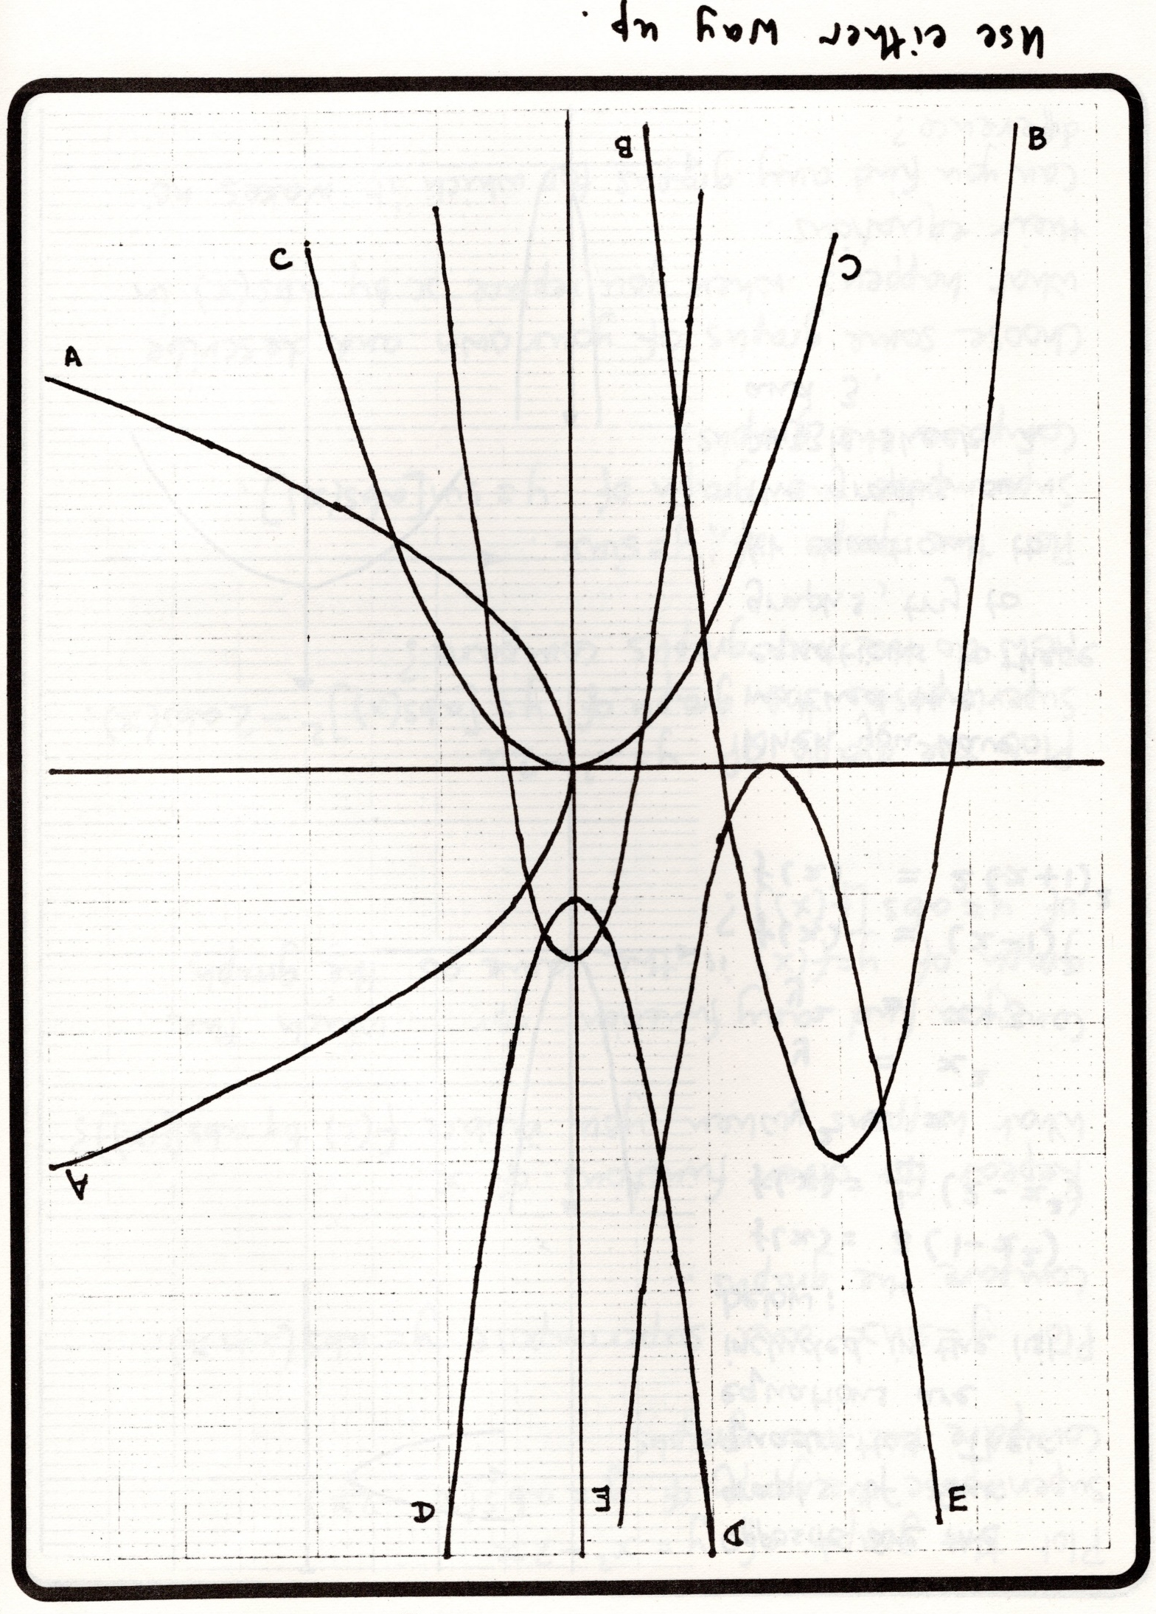
(From “These Have Also Worked for Us”, ATM P. 24)

