
Challenging topics in the new GCSE
Quadratic Relations NCP17-12

AQA GCSE Paper 2F/3F 2017

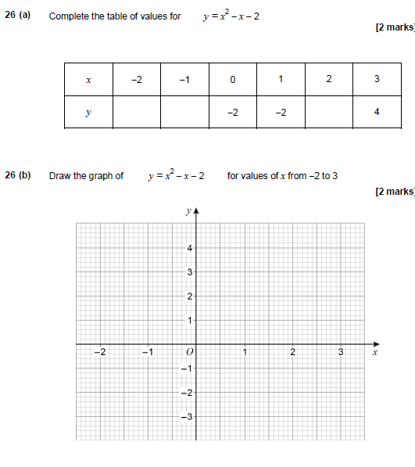

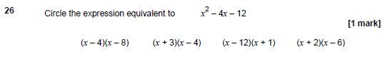

Examiner Reports

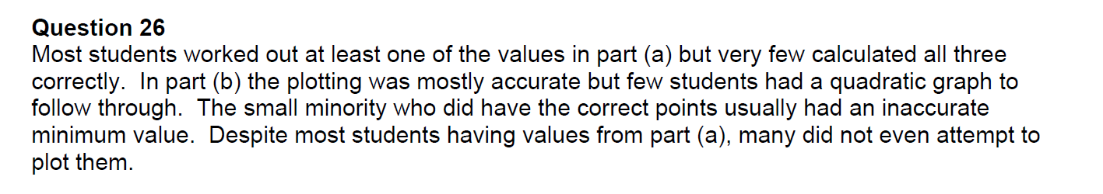

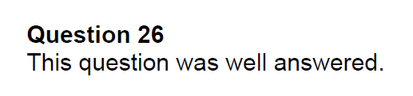

Teaching notes

