
Challenging topics in the new GCSE
Quadratic Relations NCP17-12

OCR GCSE Paper 1/2/3 (F) 2017

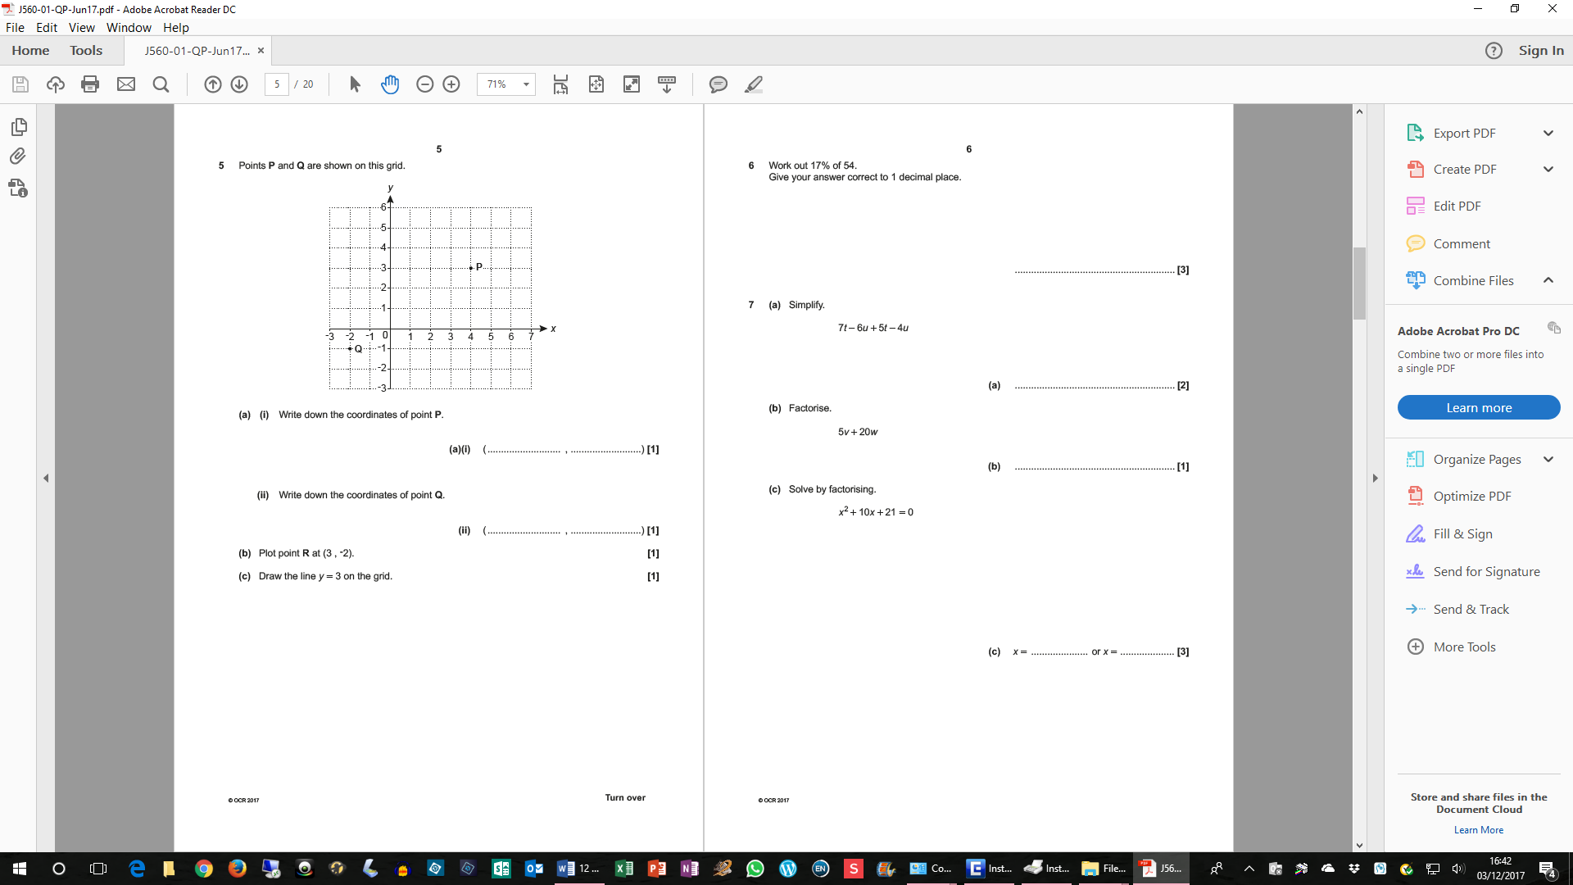
7

17

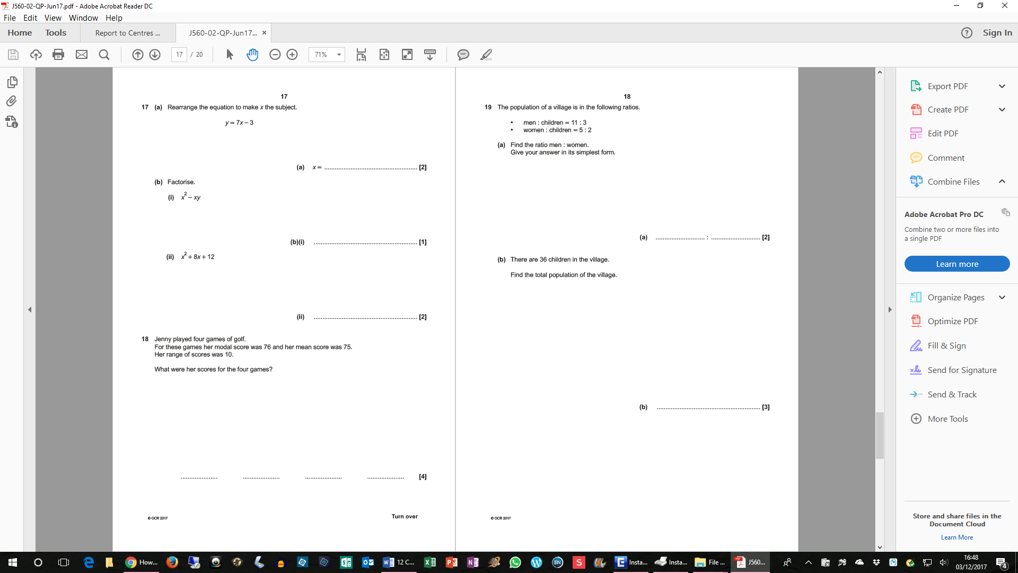

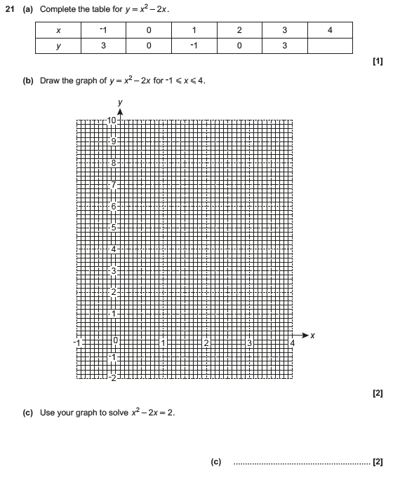

OCR GCSE Paper 1/2/3 (F) 2017 Examiner Reports

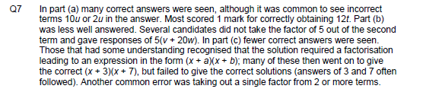
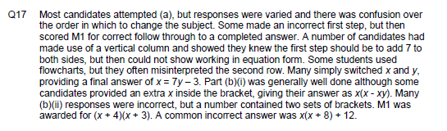

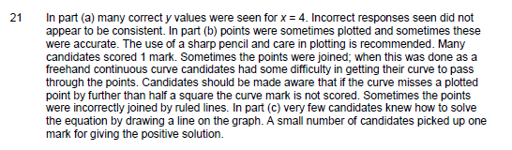

Teaching notes

