
Challenging topics in the new GCSE
NCP17-12

Edexcel F1/2 2017

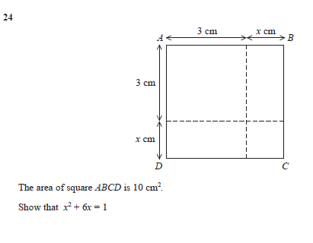

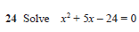

Examiner reports Edexecel F2/3 2017

F1 24
Foundation tier
This question proved very difficult for many students, even with the scaffolding of the individual sections shown on the diagram. Generally, most students scored zero, as they tried to work backwards from the given solution but with no real idea what to do or substituted various values in to the given equation. Those who scored marks normally got a single mark for two correct areas on the diagram or just below. Very few then simplified their expression and equated it to 10. The few students who did typically went on to complete the solution. It is essential that all steps are shown in a solution where the final answer is given in the question.
Higher tier
Many candidates started by attempting to multiply the 2 side lengths algebraically. Most candidates were successful after starting with this approach, setting the sum of their expansion equal to 10 and re-arranging. A significant number started by finding the areas of each of the 4 sections on the diagram, then forming an equation equal to 10 or concluding that the 3 algebraic areas would sum to 1, but some candidates failed to show sufficient working when using this latter approach. Of those unable to gain full marks, many secured the first mark for showing at least two correct area expressions or forming an initial algebraic expression for the area, i.e. (x + 3)(x + 3). The most common incorrect approach was finding the side length as 3x. Candidates should be encouraged to write down what they can see in a ‘show that’ question, making clear where expressions have come from and annotating in a clear manner.

F2 24
The method of solving simple quadratic equations by factorisation, a standard process, is now part of the Foundation level specification and should be accessible to the more able students taking this paper. A fully correct solution was rarely seen and attempts to factorise x² + 5x − 24 were seldom seen. Instead, much fruitless and incorrect algebra involving the manipulation and often combination of one or more of the three terms of the quadratic expression was common. A trial and improvement approach was common and often led to students obtaining one of the solutions (3) but not the other (−8). Students obtaining only one of the two solutions were not awarded any marks unless they had made a creditable attempt to factorise the expression.

Teaching notes

