
Challenging topics in the new GCSE
NCP17-12

Edexcel H1 2017

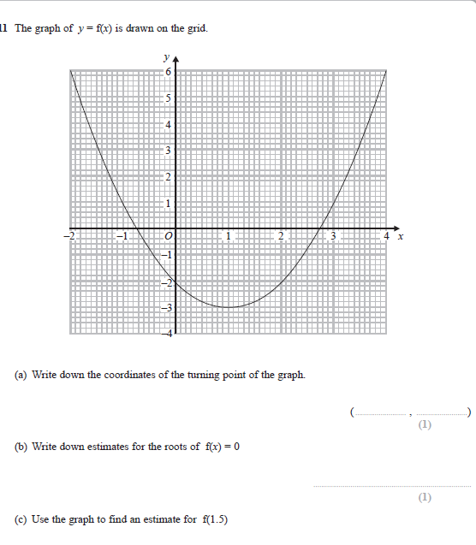

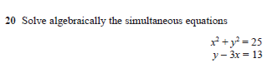

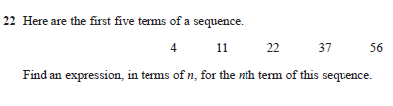
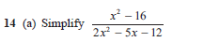
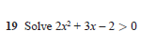
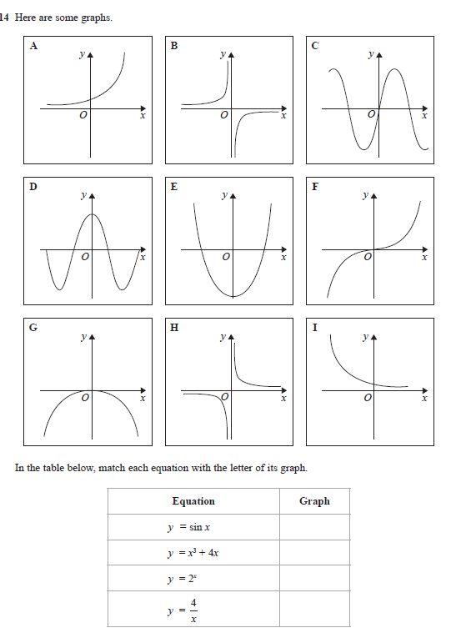
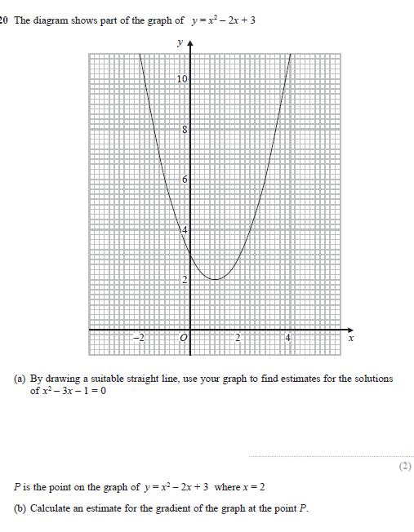

Edexecel H2/3 2017
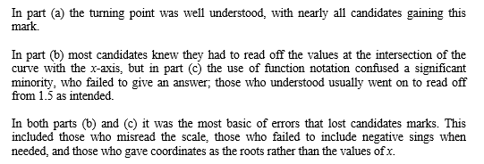
11

20. A minority of candidates incorrectly took the square root of the first equation to give
x + y = 5 or attempted to square the second equation. They were therefore unable to gain any marks. Most candidates correctly rearranged the second equation and substituted y = 13 + 3x into
the first equation, thus gaining the first method mark. They then usually expanded this correctly for further credit although a significant number of candidates expanded
(3x + 13)² as 9x² + 169. A minority of candidates failed to write the quadratic in a form that could be solved, but tried to solve their expression equal to 25. A quadratic equation was presented by many attracting the third method mark, frequently the correct quadratic equation, but the factorisation proved to be beyond many. Even those who managed to factorise found it difficult to proceed to the four values in the final solution. Many attempted to use the quadratic formula rather than factorise which resulted in the usual confusion over signs, though this was eased as all the terms of the quadratic were positive. Very few successful attempts at completing the square were seen. The final mark was rarely awarded as it involved finding all four correct values given as two associated pairs. For a complex question it was reassuring to see so many candidates have the confidence to make a real effort and often pick up most of the marks.

14. Only a minority of students gained full marks here. There was no particular pattern to the confusion that surrounded the majority of students. Many clearly simply guessed.

20. In part (a), very few students were able to derive the equation y = x + 4 from the information given. Students were generally more familiar with drawing tangents and in part (b), many students gained credit for drawing a tangent and attempting to find its gradient, often giving an answer within the accepted range. A number of students drew inaccurate tangents believing that they had to pass through the origin. Some obtained the correct solution by finding the gradient of a chord and not a tangent, this gained no credit. Some students used calculus to good effect usually resulting in a correct gradient of 2. This is outside this specification but did gain credit.

22. This question was very well answered by a great many students of all levels of ability, gaining at least one mark for realising that the sequence was a quadratic sequence. Having found the second differences of ‘4’, many gave 4n² as the first part of their nth term. Having found a correct first term of 2n², many students continued to employ a differencing approach. Others successfully arrived at a correct solution from solving simultaneous equations. Where students were not successful it was common to see 4n, 2n or n instead of 2n²; thus many two-term linear expressions.

.

Examiner reports
14., Part (a) was generally well attempted with the vast majority of students gaining at least one mark, normally for the factorisation of the two squares component. The factorisation of the other quadratic caused a problem, with many failing to obtain the correct solution often with incorrect signs seen. Some errors were also seen in the cancellation of the terms in the fraction. Also some further incorrect simplifications were seen. A common misconception still being seen is for students to just cross out part terms, e.g. x² in this fraction. Obviously this issue should continue to be addressed by centres as it is an incorrect step
19. This was the penultimate question on the paper and required solving a quadratic inequality even so almost half the students scored at least one mark on this question. The use of the quadratic formula or factorisation was correctly done by most who attempted either process. Many who applied either process then accurately identified the two critical values of −2 and 0.5. Only a small number of students were able to correctly state the two distinct regions. Those who sketched a graph and identified the two regions on the graph were much more successful in gaining the final accuracy mark. The incorrect use of inequalities or giving one continuous inequality was often seen on complete solutions. Of those that found the correct critical values only about one quarter of these students went onto give correct inequalities.

Teaching notes

