
Challenging topics in the new GCSE
NCP17-12

Concept Web

Pull together a large concept web/map for quadratic relationships for KS3-4. Include the “Big Ideas” and the elements of the “Preparing to Teach” framework below that seem important. Include pre-requisites, vocabulary, techniques, connections, links out to other “topics”, etc. Use/draw on examiner reposts for past GCSE papers.

1. What do we need to know…
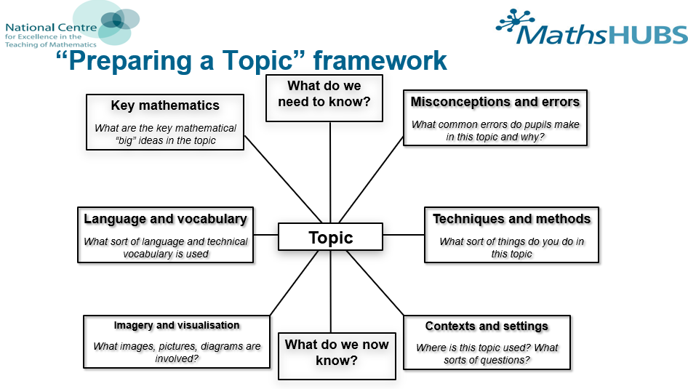

1. What do we need to know…

2. What are the key mathematical ideas…

3. What language patterns and vocabulary…

4. What misconceptions…

5. What techniques…

6. What imagery…

7. Where is it used…

