
Challenging topics in the new GCSE
NCP17-12

National Curriculum KS4

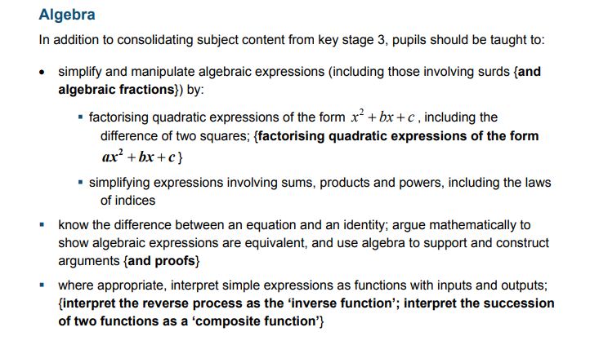
Key ideas, Connections, Foundations, Techniques, Vocabulary, Misconceptions, Diagrams, Imagery

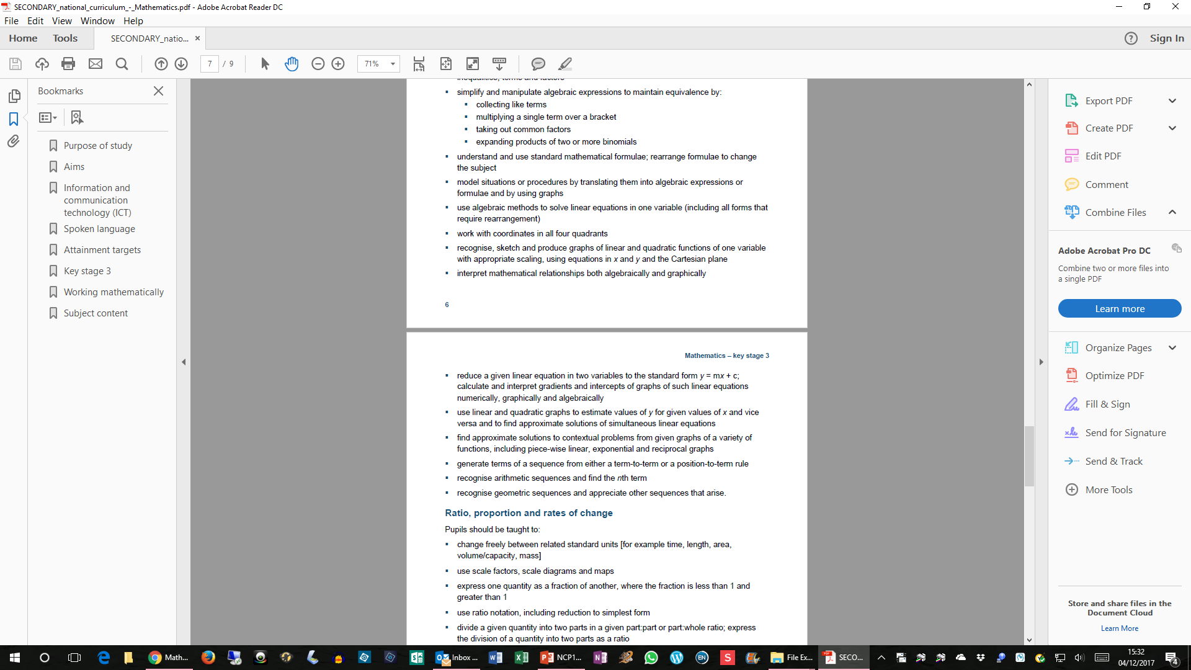
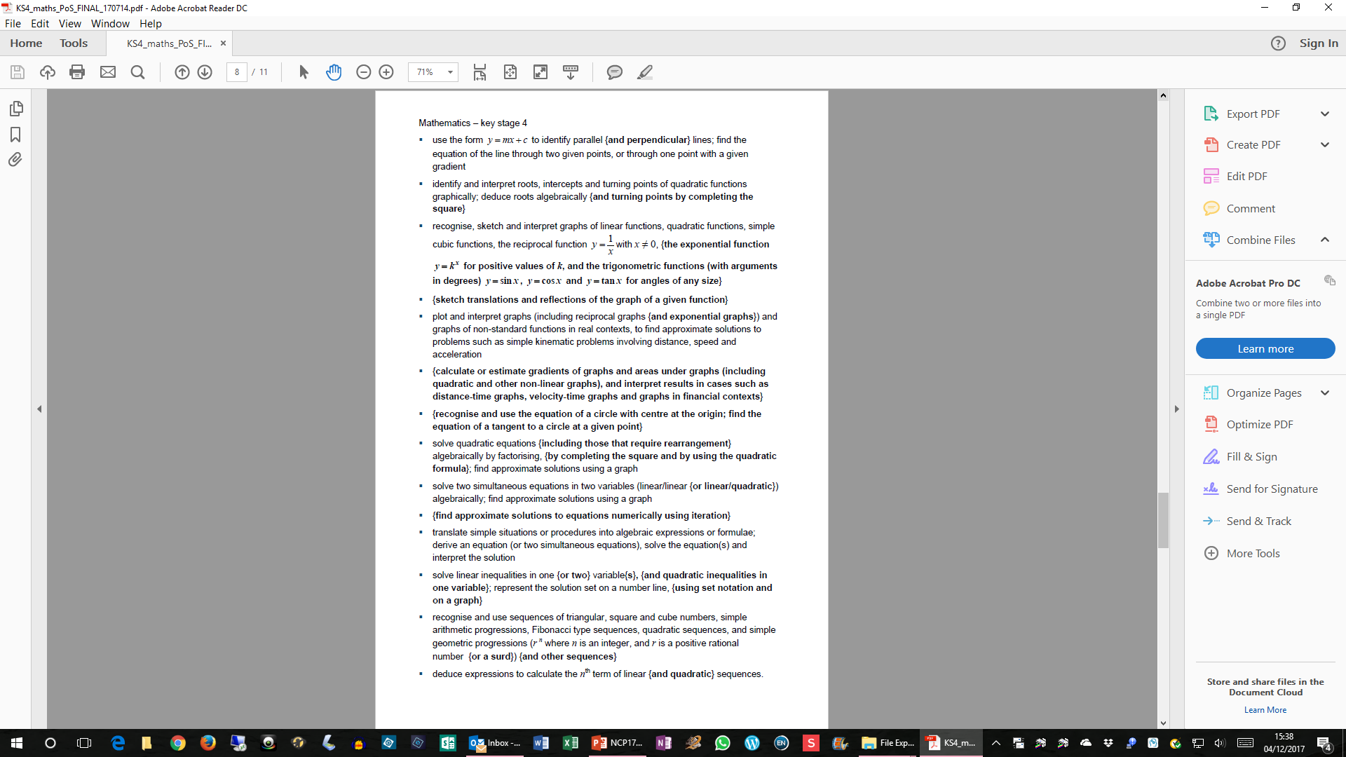
Key ideas, Connections, Foundations, Techniques, Vocabulary, Misconceptions, Diagrams, Imagery

Key ideas, Connections, Foundations, Techniques, Vocabulary, Misconceptions, Diagrams, Imagery

