From NCETM
https://www.ncetm.org.uk/Default.aspx?page=13&module=res&mode=100&resid=54109&#ItemActions
Created on 28 November 2019 by ncetm_administrator
Updated on 03 December 2019 by ncetm_administrator

Completing the square
How many times have you taught a Year 11 class how to ‘complete the square?’ Have you ever wondered what square you are completing? In how many of those lessons have you shown an actual, physical square then added some other bits to ‘complete’ it? Or has your board just got filled up with algebraic expressions?
In this article, we show how algebra tiles can give some insight into completing the square and how two teachers have used the Algebra Tiles Guidance Document from the Secondary Mastery Professional Development Materials to support their teaching.
First, let’s look at this diagrammatic representation of completing the square.
Here are some algebra tiles that represent: , , and
[dimensions by , by and by respectively].
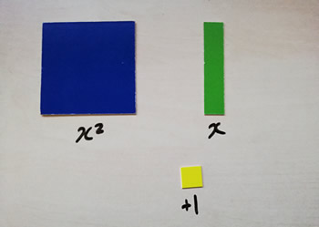

To represent the quadratic , I would use these tiles:
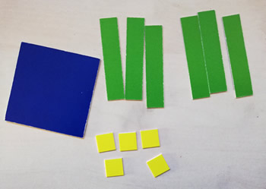

Now, if I were to try to create a square from those tiles using them all, I can see that I am four yellow () tiles short:
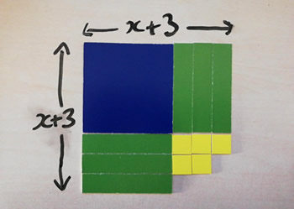
This shows that the square is bigger than the quadratic I started with, .
So, writing that down algebraically: .
Let’s just remind ourselves how we might have got to this stage algebraically.
We might have started with
But we know that
So
And therefore
Many experienced secondary teachers, who have taught completing the square many times, on seeing this diagrammatic representation say ‘Aaaaah! That’s why it’s called completing the square! I never realised!’
But for a student new to grappling with this notoriously tricky concept, is there a danger of further confusion if new equipment (in the form of these algebra tiles) is suddenly introduced simultaneously? Are we doing algebra, Miss, or are we doing area?
But what if the tiles were very familiar, because the students had used them regularly to help with algebraic manipulation throughout KS3 and KS4? This is where our Secondary Mastery Professional Development Materials can come in useful. In the rest of this article we’ll look at how these materials can help teachers design lessons using diagrammatic representations or hands-on equipment. And we’ll hear from two teachers, Erin and Steve, who’ve found the Algebra Tiles Guidance Document particularly useful.
Returning to our quadratic…

How about if our students were already familiar with using these tiles to represent the expression:

And had previously used them to represent expanding and then factorising quadratics (by creating rectangles):
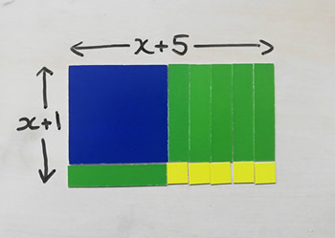

And how about if area models were already very familiar for representing multiplication?
Our Secondary Mastery Professional Development Materials suggest that area models follow naturally from supporting early understanding of multiplication with arrays:

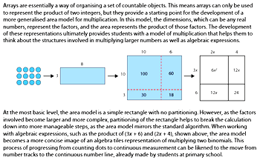

You can find out more about using algebra tiles as representations for many algebraic manipulations from our set of six videos, or this PDF from our Professional Development Materials.
You can find out more about using arrays and area models in this PDF from the materials.

Erin Butler is a Mastery Specialist and Lead Practitioner from Bishop Perowne CE College in Worcester.
With an eye on using the area model for factorising/expanding quadratics and completing the square in KS4, she describes teaching square numbers to her Year 7 classes (Set 1 and Set 7).
'I looked at this extract from the materials, where an area model is used to represent the multiplication of two expressions to form a quadratic. I thought about how this could be applied to completing the square.

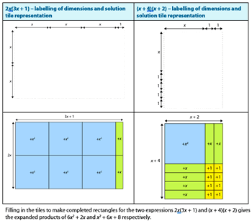

'I tracked right back to what I was doing with my Year 7 classes, learning about square numbers. I teach a Set 1 and Set 7 (of 7) in Year 7. When I checked prior knowledge with Set 1, all of them could tell me that the square root of 49 is 7, but not one of them could explain why.
'Having thought about the idea of an area model for multiplying algebraic expressions, I could see the benefit this model could have when being introduced in Year 7 with square numbers and used continuously throughout the curriculum. Students fluent in the ability to draw and interpret pictorial representations could apply this tool to develop deeper levels of understanding as they progress though the different stages of their education, applying this to concepts seen in the higher tiered GCSE content. This is what inspired me to teach square numbers pictorially.
'When learning about squares and square roots, we physically made, on our whiteboards, a square one by one, and we talked about ‘’ discovering how that physically created a square. We continued to create squares (two-by-two, etc) and linked our discoveries to the properties that make a square. We discussed how some numbers get the name ‘square’. Because they make a square!
'This gave me an opportunity to talk deeply with them about inverses, what makes a perfect square, what the difference is between a square number and squaring a number, between square rooting any number and square rooting a perfect square.
'With Set 7, I started in the same way, by drawing pictures. They struggled to understand that the dimensions didn’t represent the square number. They had their ‘lightbulb moment’ when I asked them to prove whether 5 was a square number. They discovered that no matter how they manipulated the picture they could never create a square using 5 tiles.'
About the Professional Development Materials, Erin says:
'I find the materials really useful to understand the development of a concept, so that you can establish the foundation skills in KS3 that will enable understanding of more complex ideas in KS4. If I look further up the curriculum, it helps me understand how to teach the younger students. Building familiarity with representations in KS3 with more simple concepts is the key to using them to unlock more complex concepts in KS4. Students are able to make connections with what they already know.'

Steve Harvey is a Mastery Specialist and Head of Department at Wolverley CofE School in Kidderminster. With his top set Year 11 class, Steve wanted to try out using algebra tiles that he had read about in the Mastery Professional Development Materials.
'We had already been looking at completing the square algebraically in a previous lesson, and I had been reading the document from the materials on algebra tiles. I wanted to see what my Year 11 top set could make of the tiles and if they could relate them to what they had learned about completing the square.
'This was the relevant bit of the document I had read:

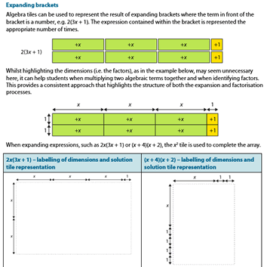

'I gave the students an tile, six of the tiles and eight of the tiles and asked them to try to make a square. We talked about completing the square and what we had done previously, and then I asked them to show me how the tiles could represent completing the square.
'They kind of had an idea of what they were getting to, but all of a sudden, by actually completing a physical square, it made it so much more tangible, so much more understandable to them. I felt a bit daft that I’d never done that [when teaching completing the square] before.
'Then one student said, ‘I’ve made a rectangle, Sir!’
'I asked him what he could tell me from that. He paused and then said ‘Oh… I can expand and factorise!’
‘If I don’t make a square Sir, and I make a rectangle instead, then I’ve got an and so many ’s and the number on the end’. You could almost see the ripple across the classroom. It really inspired their natural curiosity and created a tangible excitement.
'Suddenly, students were making connections and allowing me to see things in a way that I hadn’t seen previously. This is where the PD Materials are so strong – for developing teachers’ subject and pedagogical understanding as well as students’ maths.
'Following this lesson where all students had explored using the tiles, I used the tiles as an option in future lessons. More confident students used them once or twice. Less confident students found it reassuring to use them a lot more.
'I went in at the deep end with my Year 11 students and now I am working backwards from there to see what we could be using the tiles for as a department. In future, I think they should be introduced in Year 7 to breed familiarity with the equipment. I would introduce them to collect like terms and use them regularly after that, so that students are comfortable to use them to delve into trickier concepts as they progress.
'In terms of using the PD Materials with my department, we have sat together to discuss using the algebra tiles to represent completing the square. The reaction of my colleagues was much like my own – why haven’t we done this before? This is amazing!
'We will be using the materials more over the coming year. I like to try things first before I introduce them to my department – my colleagues like to be confident that they are being introduced to tried and tested ideas backed up by research.'
As well as guidance on using algebra tiles, the Professional Development materials contain guidance (PDFs and videos) on Cuisenaire Rods, arrays and area models, bar models, Dienes (and place-value counters), double number lines (and ratio tables), the Gattegno chart, place-value charts and single number lines.
You might also like to listen to our podcast Making the most of our new secondary mastery materials, in which the authors explain how the materials can help departments and teachers develop their maths pedagogy to teach for deep and connected understanding.

Comments
14 January 2020 16:17
This is interesting stuff and should provoke some lively discussion. I have some reservations about this approach.
1. You haven't really set out why we would want to use this method. Isn't the reason for doing so to help us solve quadratic equations (not merely manipulate quadratic expressions)? And isn't the key idea here that, if we can't factorise the LHS of a quadratic equation (where RHS=0), we want to re-write the equation in such a way that the unknown (x) appears only once. If we can achieve this, then, by applying a series of inverse operations, we should be able to isolate x. You come close to actually showing a way of achieving this, which, in the case of x²+6x+5 involves writing this as (x+3)² + A Number. Once the reason for doing this is clear, I would have thought the algebraic symbolising becomes fairly straightforward. Do we really need the geometric model??
2. The geometry explains why the method has the name that it has. That's nice to know, though it doesn't necessarily illuminate the process.
3. The area model is powerful, but it takes a lot of (worthwhile) work to understand it. The algebra tiles model might be powerful too (maybe), but it is even harder to understand, especially the idea that a specific size of tile can represent an unknown quantity, and that some tiles seem to represent 'square' quantities and some 'linear' quantities. Sensibly, you make the point that the Algebra Tiles approach is more likely to make sense to students if they have used the tiles regularly in KS3 and 4. I think that is probably true, at least to the extent that the approach will almost certainly be hard to understand if students aren't familiar with the Tiles. I still wonder though, whether the tiles add much to the 'purposeful' symbolising approach outlined in point (1).
By DietmarKüchemann

15 January 2020 10:42
This is really helpful, Dietmar – thank you.
Your comments have made me reflect on different aspects of working algebraically which students need:
- Having an understanding of variable;
- Appreciating the meaning of certain manipulations
- Appreciating the purpose of certain symbolic manipulations and why they are useful
- Developing a fluency with symbolic manipulation
... and the article does focus more on some of these aspects than others.
An important point to consider, I guess, is that any representation can never get to the heart of an abstract mathematical idea or concept as its concreteness is fundamentally at odds with the abstractness of the idea it is attempting to stand for. So, encouraging students to work with the symbols alongside the tiles is critical so that in moving backwards and forwards across the ‘bridge’ between the worlds of tiles and symbols some meaning is made and some fluency achieved.
The teachers’ accounts do seem to indicate that students found the tiles helpful in both helping them to make meaning and to attain some fluency.
Let’s hope this does produce some lively discussion. Comments and responses very welcome from anyone who has read the article.
By petegriffin

03 February 2020 12:55
This works well for the coefficient of x as an even number but becomes less intuitive when it is odd. Try x^2 +3x -1
And when the coefficient of x^2 is not 1?
By Phil.Wall
06 February 2020 10:16
I agree with you that this model breaks down for more complex examples. I think models can be helpful with simple cases to enable understanding of structure. Sometimes models can be adapted for more complex cases – some use the reverse side of algebra tiles to represent negative terms, for example. But for me this all becomes a bit too contrived and I find myself caught up with trying to see how the model represents the maths, rather than with understanding the maths itself. I would suggest that instead of trying to make the model fit the more complex cases, we should be encouraging a more abstract understanding that allows for all complexity. We shouldn’t feel that all our understanding has fallen apart because the model will only take us so far.
I have also found that if new equipment/models are introduced with a new concept, the model can become a distraction from the maths and create confusion rather than clarity. Hence my advocacy, in this article, for introducing the area model early and using it continuously so it is a vehicle to introduce new maths, not a distraction from the maths.
By Gwen_Tresidder

